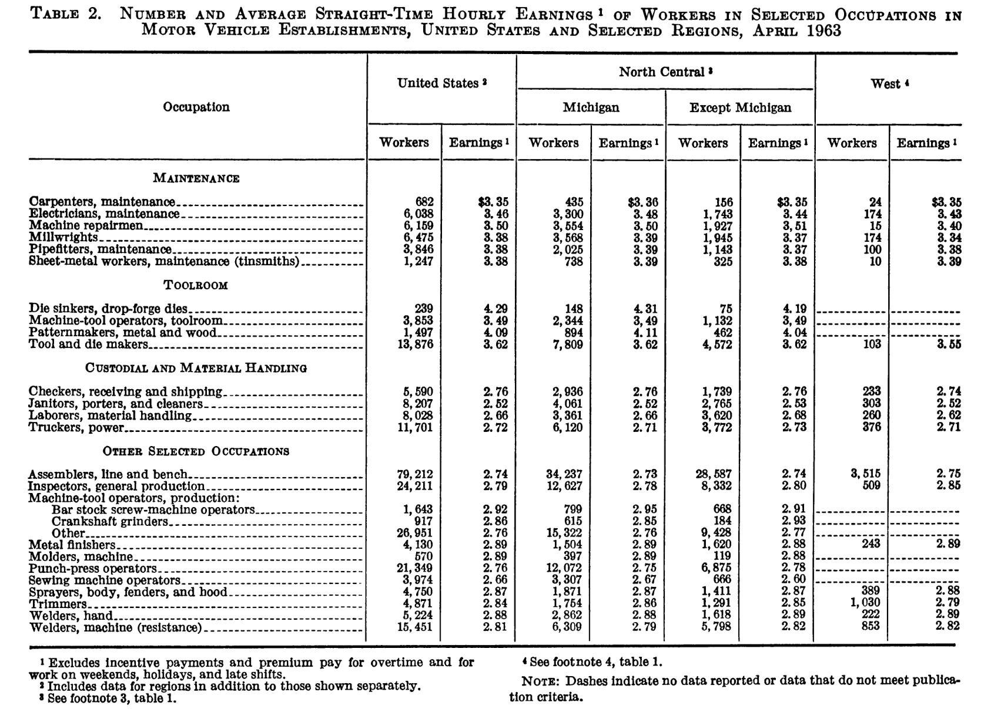
Lewis, L. Earl, and Frederick L. Bauer. "Wages in motor vehicle and parts plants, April 1963." Monthly Labor Review(1964): 163.

